A MESSAGE FROM THE CEO
YOUR SATISFACTION, OUR PROMISE
With every successful engagement we deliver, I take more pride in our growing company, satisfied clients, supportive partners and dedicated team. Since its inception, we have been blessed with working side-by-side with our partners as a unite family to bring real value to our clients, provide them with high-quality services, cutting-edge solutions and help them overcome their business challenges. Our process oriented and customer focused approach remains one of our many strengths that make BlessedTree a preferred and trustworthy management solutions provider to many clients across the region in various industries.
knowledge transfer & capacity building have been always a top priority in all our engagements, our goal is always to leave you with appropriate methodologies, capable resources and right solutions you need to realize your strategies, improve performance and achieve your business goals.
On the behalf of all BlessedTree family, your satisfaction is our promise!
SHADI KAYALI
CEO & Founder

ABOUT BLESSEDTREE

OUR COMPANY, OUR WORLD
Blessedtree is a team of capable professionals who excel in collaborating across borders to bring value to clients. For years, we have been a trusted management solution provider for many clients in public and private sector.
Based in Amman – Jordan and covering the entire GCC, Levant and North African region; Blessedtree continues to fulfill its founding principles that our success stems from our trustworthy relation with our clients, our capability to live to their expectations and turn them into long-term partners.

OUR MISSION
"To become the premier choice at middle east for organizations seeking performance management solutions"

OUR VISION
Achieving ultimate costumers loyalty via providing best of breed performance management solutions globally

OUR VALUES
  - Contribution & Client Focus
  - Commitment & Accountability
  - Integrity & Team work
  - Respect & Transparency
  - Innovation & Creative

OUR FOCUS
Our focus is to have our experts work together with your business and IT teams to get to the heart of your strategy & performance processes and develop the most adapted solutions to your requirements. We believe this process-centric approach is what makes a real difference for your business.
We believe strongly in specialization, and have oriented our organization to deliver world-class services and solutions in strategy, performance and project portfolio management. We are rigorous in bringing you the best value possible, not just another piece of ready software.

OUR TEAM
We combine in one team all skills required to successfully work with our clients business and IT people to deliver highly efficient management solutions tailored just right to their needs. Our aim is to deliver not a only software but a total management solution that makes a real impact.

Our utmost priority is to bring you value. This is why senior management take hands-on leadership roles in all of our work. At BLESSEDTRE, Every engagement is the most important one.
we have people who are highly capable and motivated to work alongside clients on their governance and performance challenges and deliver the right solutions, our affiliation and deep understanding of the region culture makes it easier for us to team up with our clients to bring them the best results.

YOUR INDUSTRY
Our innovative management solutions are easily implemented to help manage transformation, improve governance and shift performance in various types of industries

Government | Communication | Automotive | Banking | Manufacturing
Education | Insurance | Healthcare | Retail | Utilities

OUR OFFERING, OUR STRENGTH
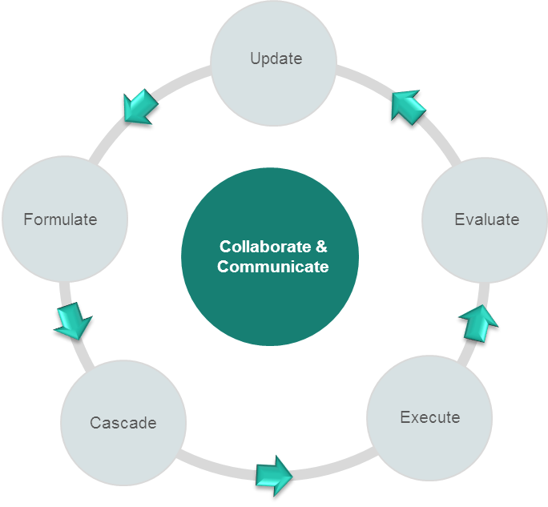
BECOME MORE STRATEGY FOCUSED
Whatever the strategy or performance management model you choose to implement, from Balanced- Scorecard to a simple performance tracking model, we can support them all.
With our solutions, managing your entire strategy lifecycle was never easier. We can help you:
- Align your entire organization around a shared vision.
- Make sure you strategy is always balanced, aligned & focused.
- Easily and at anytime update strategy components and performance targets.
- Stay always aligned to corporate or national strategies or respond to changes in environment or directions.
- You can easily communicate and collaborate with all levels in your organization, and above all, track your strategy achievement at any time and from anywhere.

IMROVE YOUR CORPROATE GOVERNANCE
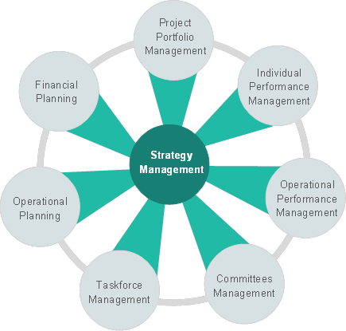
Improving corporate governance is gaining more and more attention as never before. With strategy as a key governance component, our solutions help you:
- Enhance transparency level and increase organizational agility.
- Set, align and evaluate performance on the operational level.
- Set, align and evaluate performance on the employee level.
- Integrate strategy with operational and financial planning.
- Manage board meetings and corporate forums
- Effectively manage and align internal taskforces.
- Manage and track enterprise risk KPIs.

SHIFT YOUR ENTERPRISE PERFORMANCE & GET INSIGHT TO BEHIND THE SCENES
- Automate corporate performance management processes.
- Make use of the most advanced, interactive and informative dashboards.
- Get timely information and produce informative performance reports with a click.
- Provide decision makers with precise on-time information on performance on all levels.
- Use intelligence to increase your visibility of your business and organization.
- Use performance scorecards to manage performance on strategic and operational level and cascade performance targets on the employee level.
- Utilize performance data to drive improvement.

MANAGE PROJECTS & OPTIMIZE YOUR PROJECT PORTFOLIO
With our Project & Portfolio Management solution, you can easily align your projects and manage your business investments. We can help you reap big results.
- Assess and justify new projects ideas.
- Keep stakeholders engaged all the time.
- Group and align your projects to strategic and operational plans.
- Manage project procurement cycle.
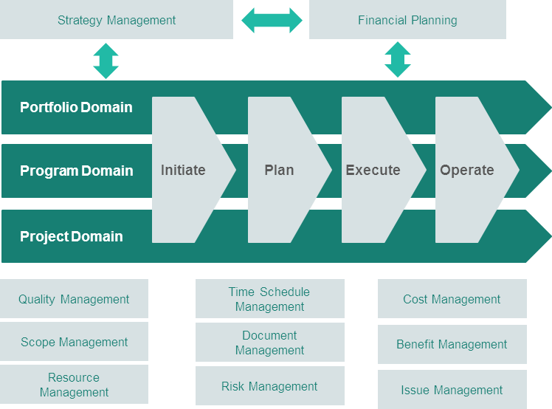
- Control projects delivery.
- Manage projects quality.
- Control changes to your projects.
- Manage projects financials.
- Manage projects risks and issues.
- Manage projects benefits.
- Enhance project communication.
- Make project handover smoother.

ENHANCE CORPORATE COLLABORATION
Corporate collaboration, communication, and teamwork are all key to your strategy success, nothing stand in the face of your strategy as much as organizational barriers. We can help you:
- Create a more collaborative culture.
- Improve cross teams collaboration & communication.
- Track cross teams performance and leverage their productivity.
- Make sure your teams are always aligned and engaged.
- Manage team formulation, evaluation and closure.

STAY CONNECTED, STAY INFORMED
With our interactive Decision Support System mobile application, stay informed on your corporate performance any time and from any where
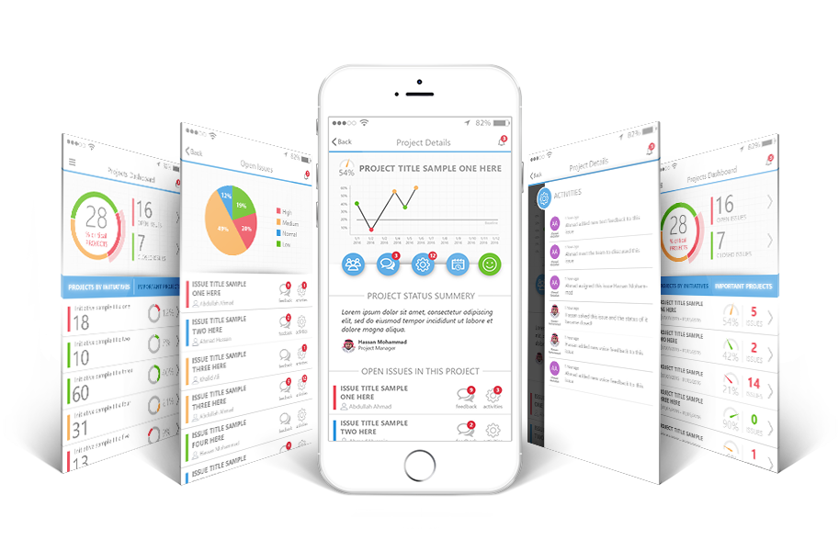

OUR SOLUTIONS, OUR EDGE
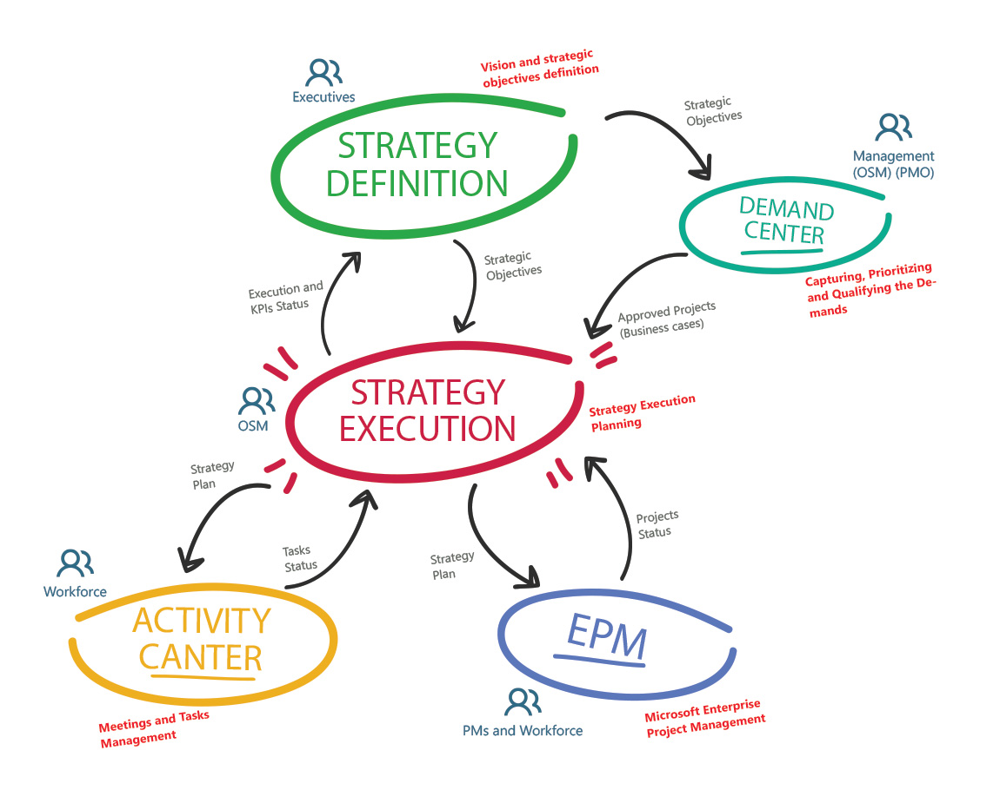
Our cutting edge and powerful solutions support you pursue to realize strategy, achieve value and maximize return on projects, enhance enterprise alignment and improve performance enterprise wide. All of this with your process always at the heart, It is where it all begins and ends!

- Cutting-edge technology  - Visually rich interactive dashboards.  - Advanced reporting capabilities  - Short implementation time  - Full customization and easy configuration.  - Ultimate user experience.  - Bilingual easy-to-use interface. | - Full integration with Microsoft environment.  - High performance & scalability  - Advanced search capabilities.  - Powerful administration module  - Role-based access control.  - Role-based system notification.  - Powerful mobile DSS module

OUR CLIENTS, OUR PRIDE
From various sectors and all across the region, we are proud of the many success stories we delivered in partnership with our clients. Read what they had to say:

“We have selected Blessed Tree as a projects partner to help us meet customer needs. We loved how they showed interest in our work; not only from technical point of view, but also investing in our business goals and strategy. We were very satisfied with Blessed Tree project management capabilities, too”  Saif Alomari  Partner, Consulting Manager  Devoteam ME |  |  | “I thank Blessed Tree for its success in implementing scope of work required by us. Since the beginning, Blessed Tree has shown full applicable knowledge of bridging the gap between technology and business. Blessed Tree’s rapid and successful implementation of the projects contributed to achieving our transformation objectives”.  Nagy Hamamou  Excellency and Transformation Manager  PwC ME
“I worked with Blessed Tree Company for a long period. In addition to thinking with their client innovatively, they are accountable and capable to deliver all their promises”  Imad Alsadeq  Partner, Management Consultant  Araamis |  |  | “I worked with Blessed Tree Company for a long period. In addition to thinking with their client innovatively, they are accountable and capable to deliver all their promises”  Hesham Alhassoun  PMO and strategic Director  Ministry of Social Affairs

Sample of Government Clients – Kingdom of Saudi Arabia
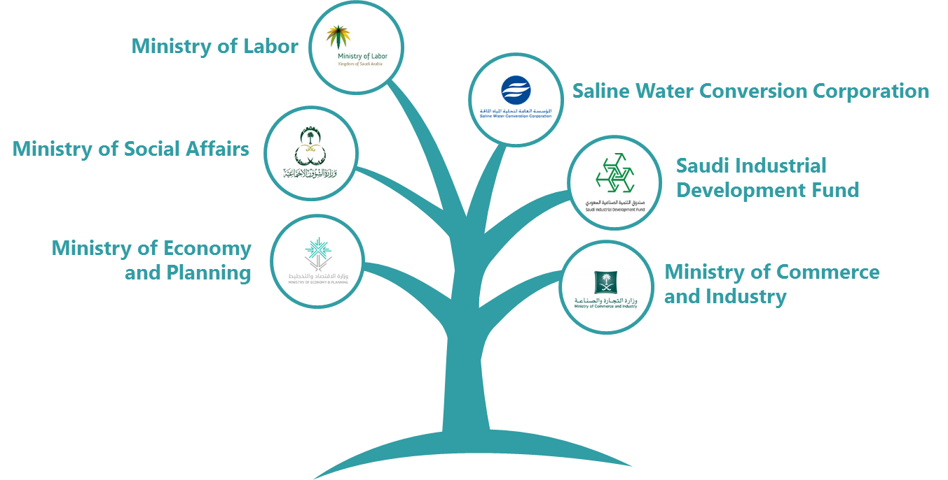

Service & Channel Partners
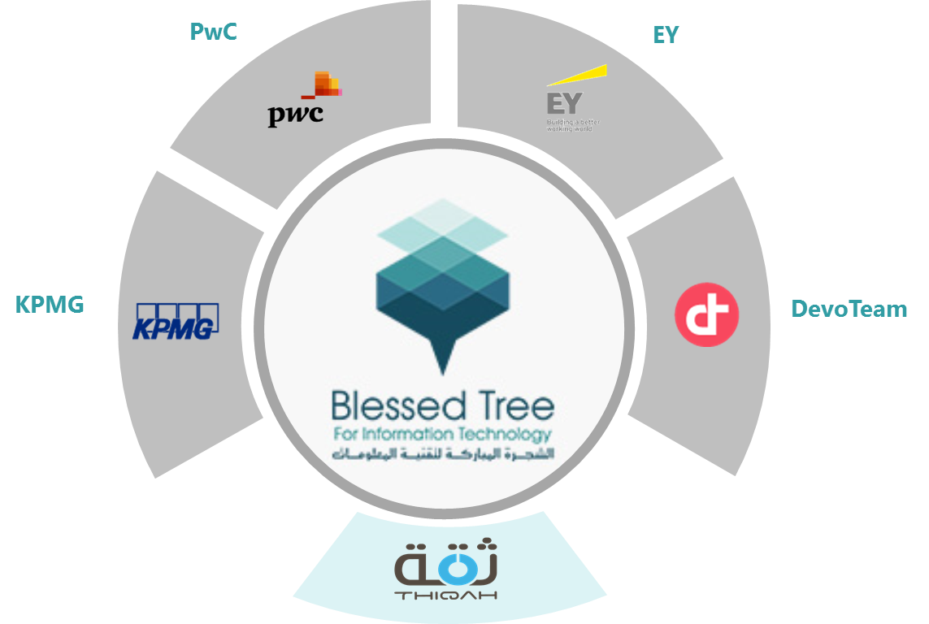

CONTACT US

Phone: +96265521016
Fax: +96265521019
Mobile: +962796885595 | +966540064334
Email: info@blessedtreeit.com
www.blessedtreeit.com | P.O. Box 7919 Amman 11118 Jordan

